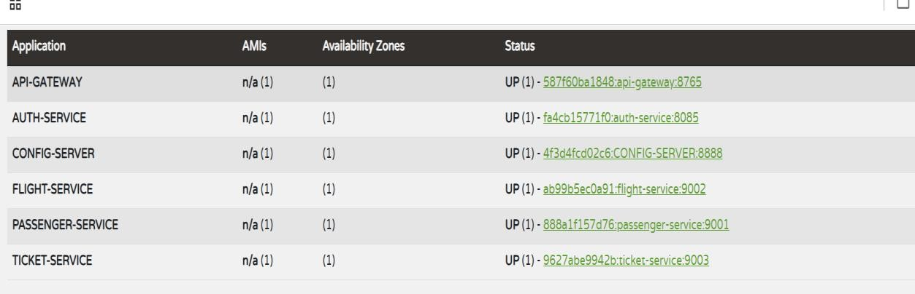

MY HOME SCREEN:



After clicking sign up :

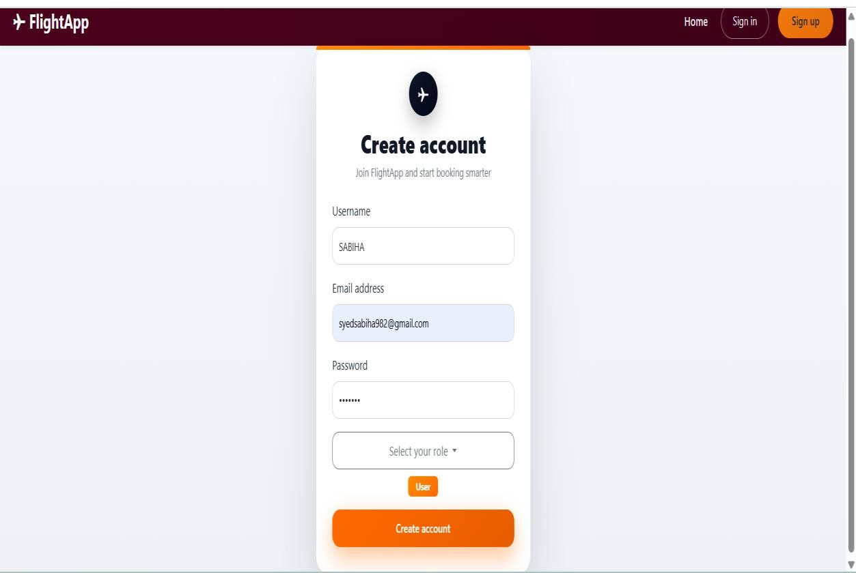

Here when we clicked create account page will be redirected to sign in :
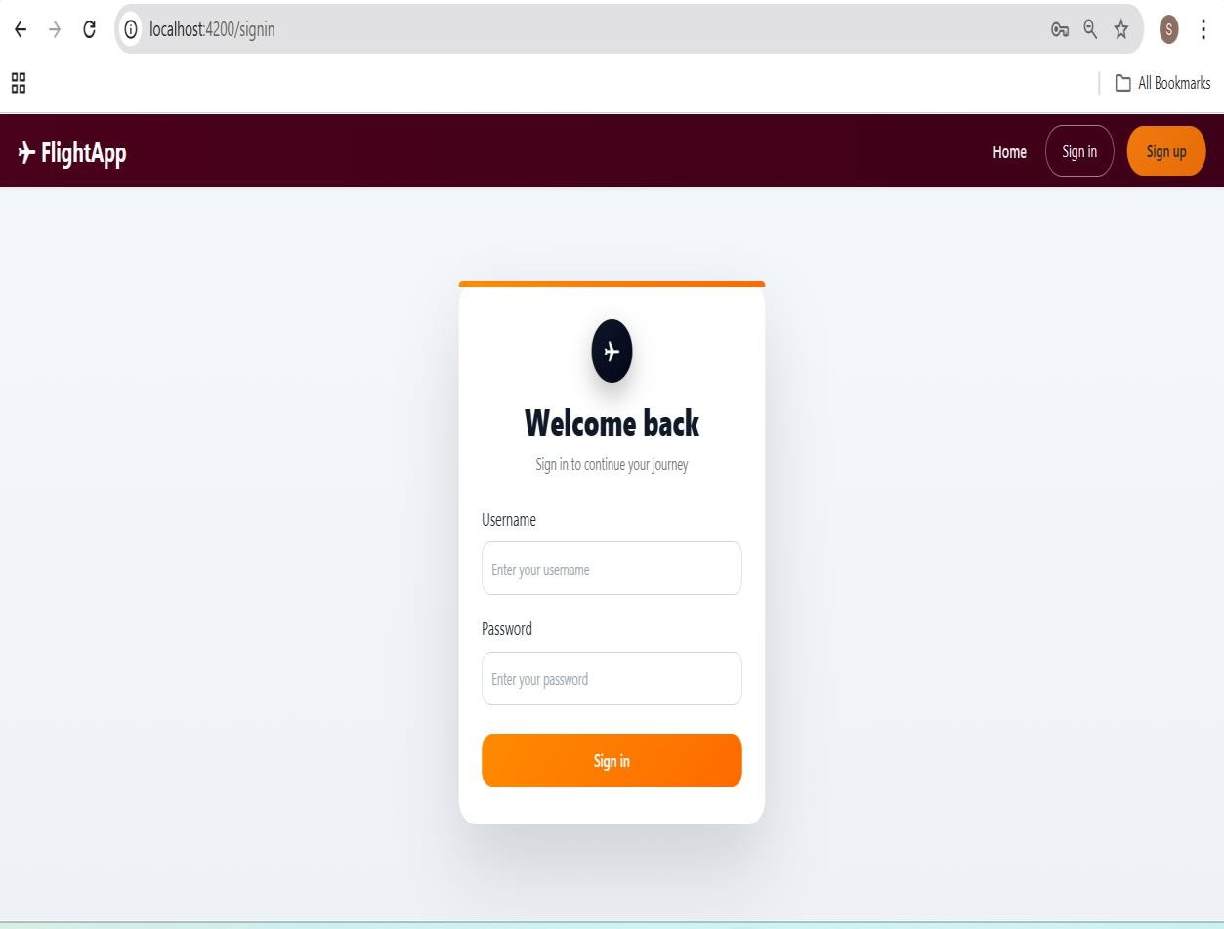

We need to enter details:

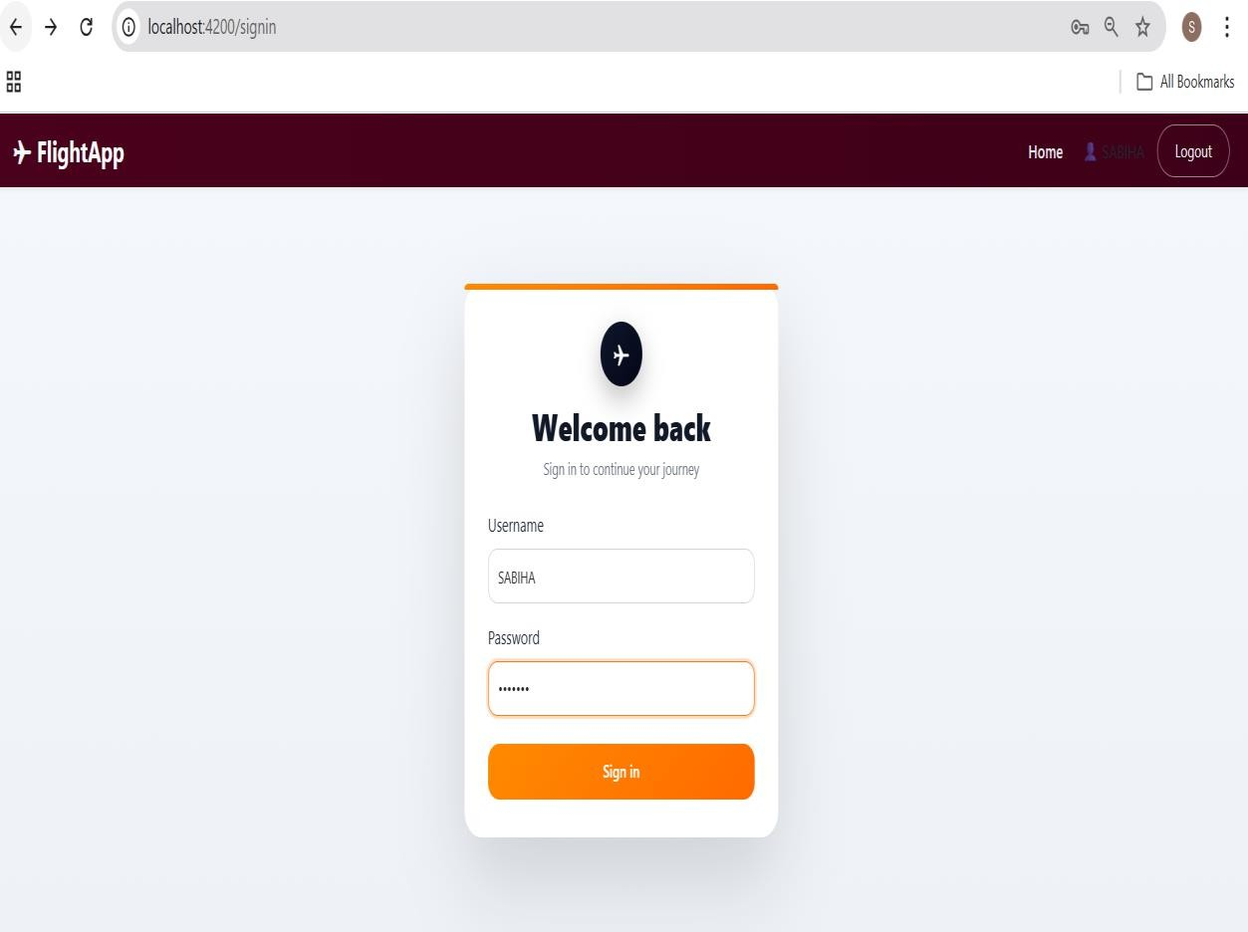
After sign see the navbar buttons will be changing:

We need to search flights enter origin and destination:


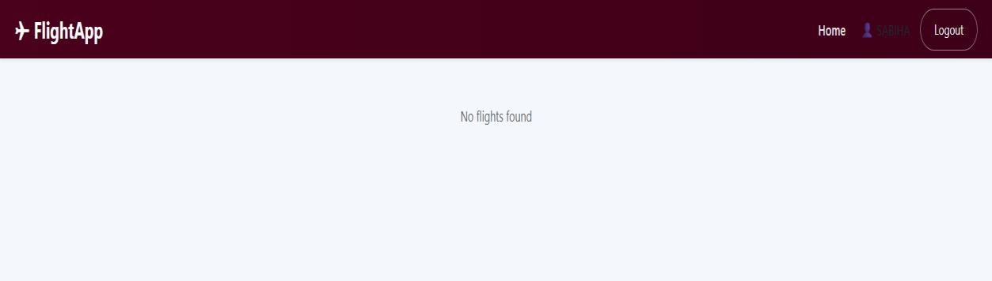
Since no flights are there

Searched for Goa to Chennai:
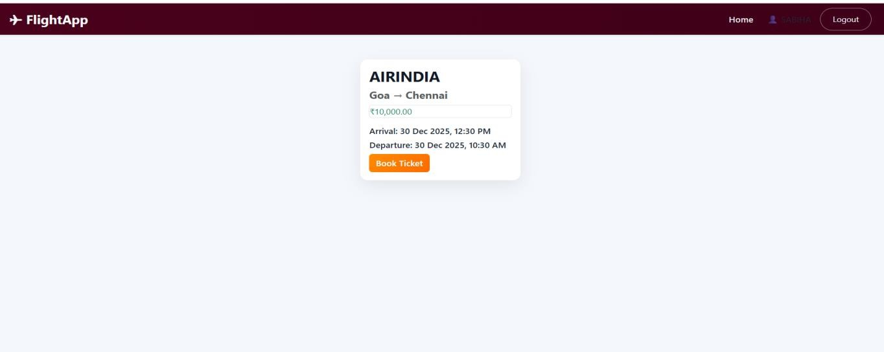

If we clicked book ticket:
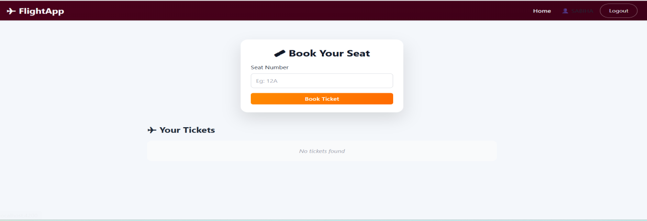
when we clicked book ticket:
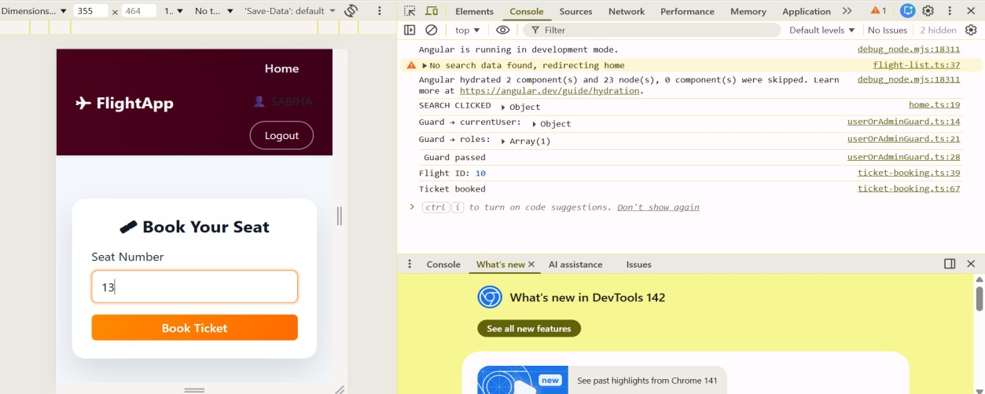
Ticket is booked console msg
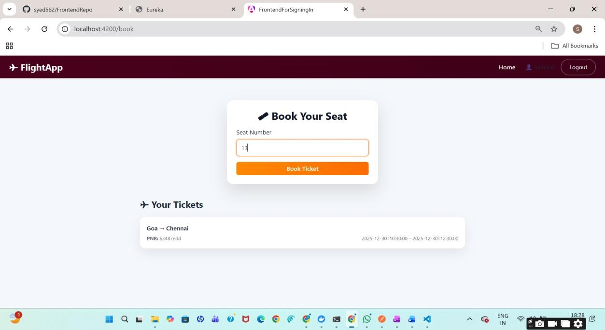

VALIDATIONS CHECK
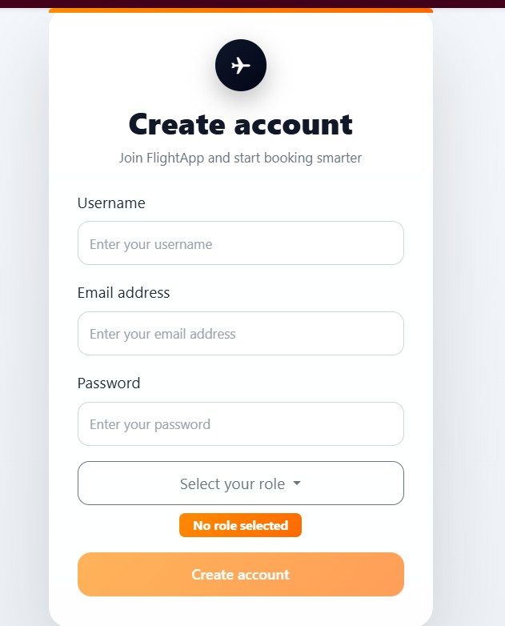

As every field is black create account button is not activated

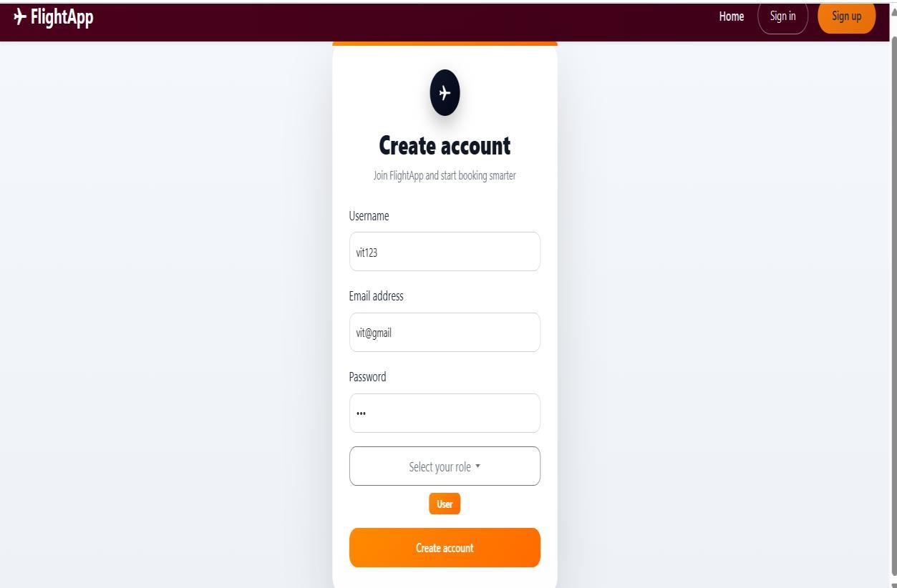

See here email is not correct and password length is 3 that’s y failed Conditions are:
Field | Validation Implemented | Rule Applied | How It Is Implemented
Username | Required | Cannot be empty | required attribute on input
Username | Minimum Length | At least 3 characters | minlength="3"
Username | Pattern | Only letters and numbers | pattern="^[a-zA-Z0-9]+$"
Email | Required | Cannot be empty | required attribute
Email | Email Format | Must be valid email | type="email" and email
Password | Required | Cannot be empty | required attribute
Password | Minimum Length | At least 6 characters | minlength="6"
Password | Pattern | Must contain number & special character | pattern="^(?=.*[0- 9])(?=.*[!@#$%^&*]).+$"
Role | Required | User/Admin must be selected | Checked using selectedRole

NOW FOR SIGN-IN:
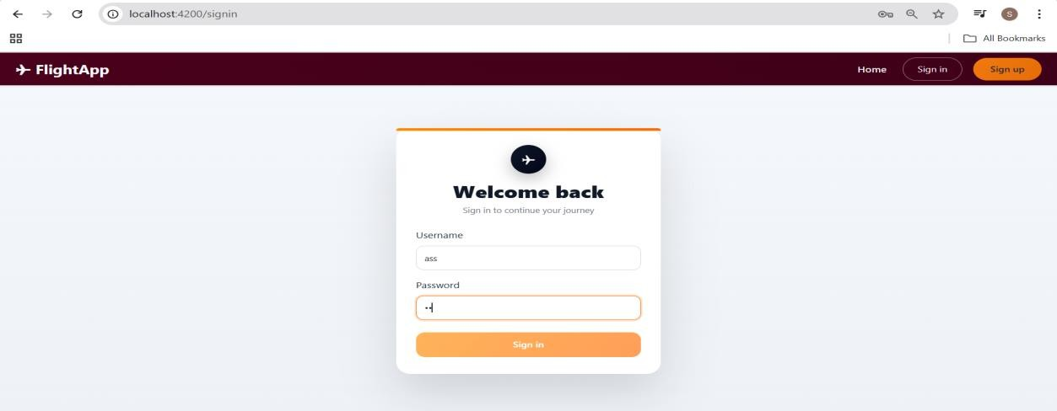

See here username is less than 3 and pass is weak one

When I entered wrong cred:
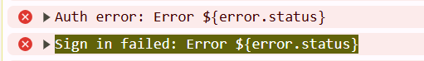

Field | Validation | How it’s enforced
Username | Required | required
Username | Min length 3 | minlength="3"
Password | Required | required
Password | Min length 6 | minlength="6"
Form | Prevent submit if invalid | [disabled]="loginForm.invalid"
UX | Error messages | touched + errors

Now FLIGHT SEARCH :
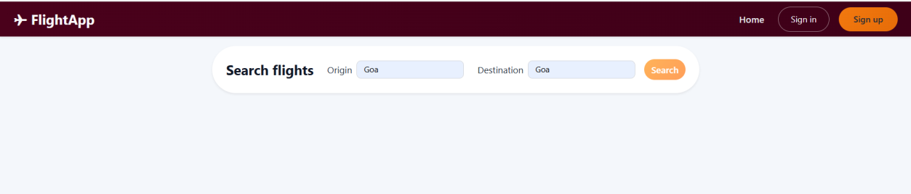
As I entered same place in origin and destination search button is not active

If different places search button is active

Only admin can add flights:
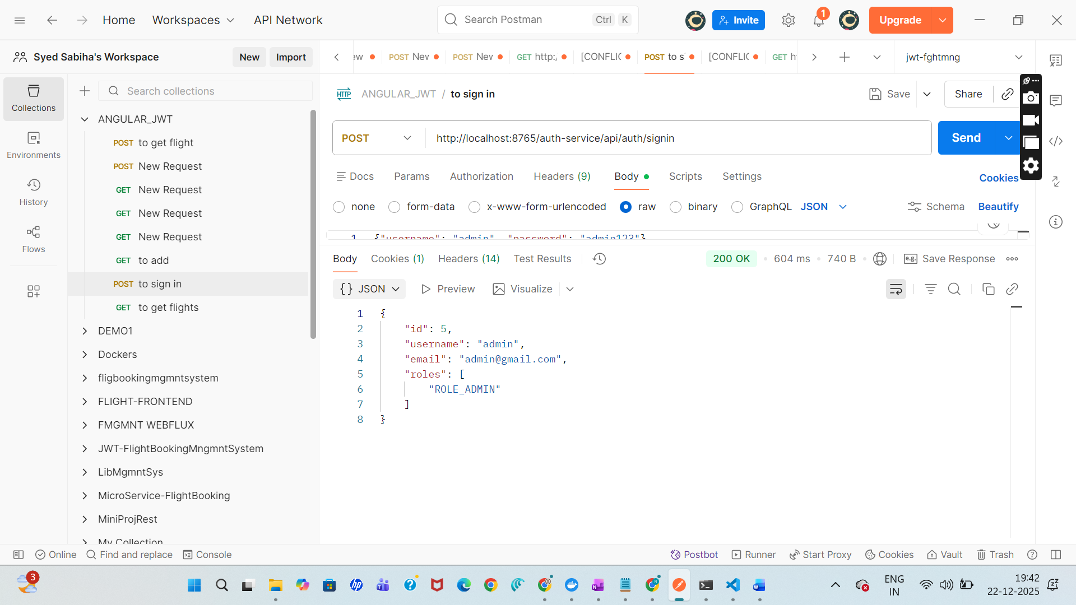
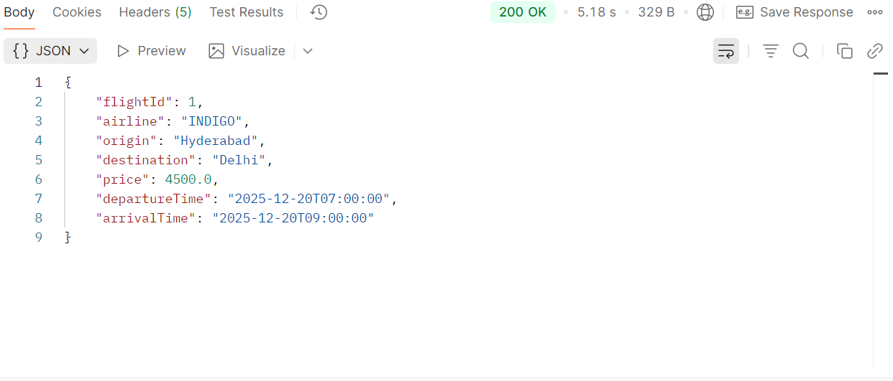
When I add flight as user
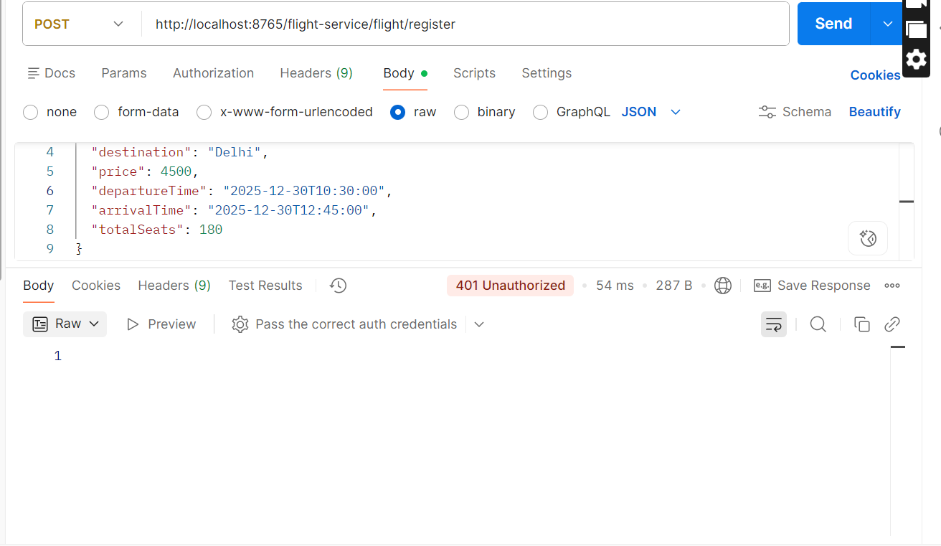

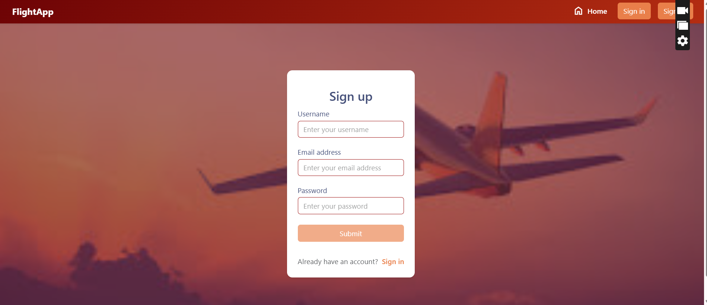

Only login as user as admin not possible:
When we login as admin then only flight inventory will be visible

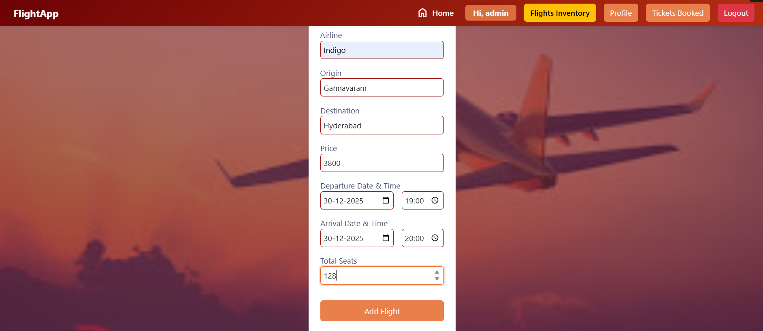

Change password:

